Tổng Hợp Kết quả

Báo cáo kết quả train mô hình Trên tập TON-iot
Decision Tree overall accuracy: 0.95.
Bagging Classifier overall accuracy: 0.97.
Random Forest overall Accuracy: 0.9374
Best :LightBGM train_acc: 0.96
Best XGBoost train_acc: 0.9812
Best SVM train_acc: 0.8622
CNN Best Acc : 0.9179
RNN Best Acc : 0.8116
Best Transformer train_acc: 0.9416
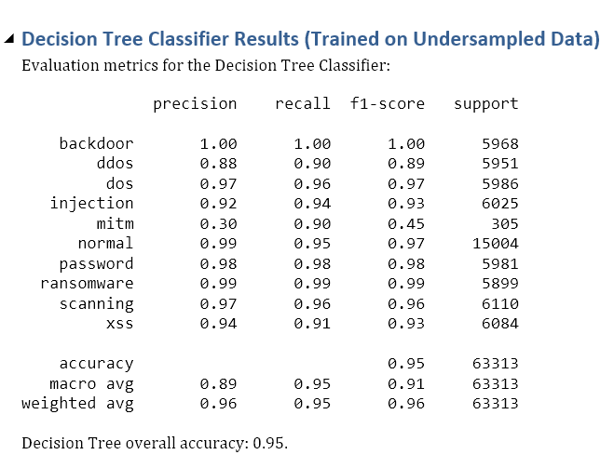
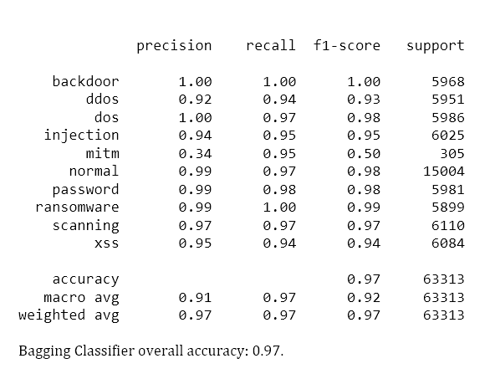
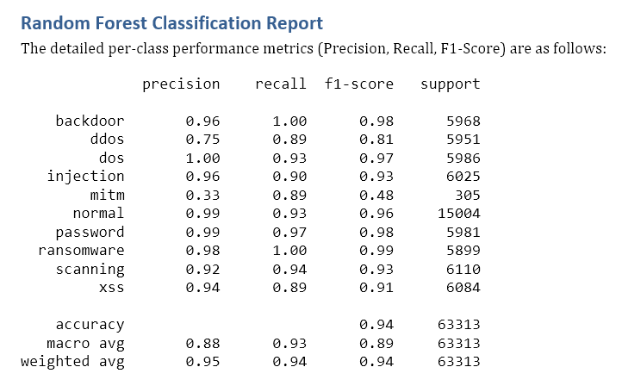
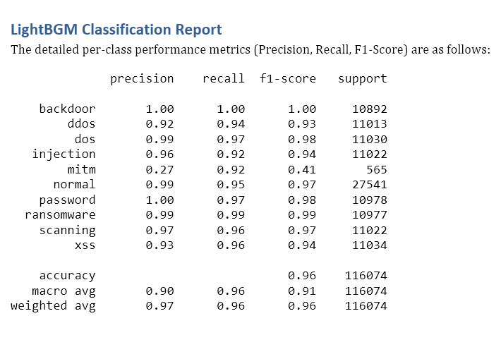
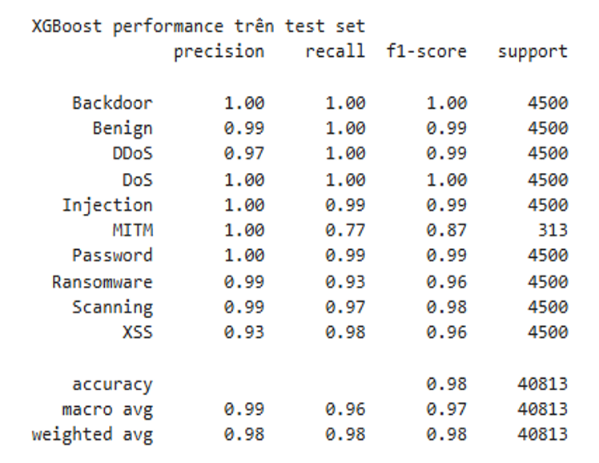
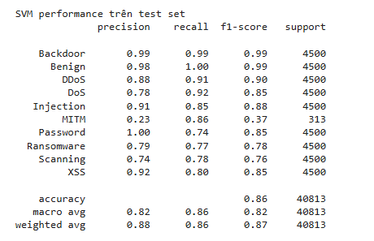
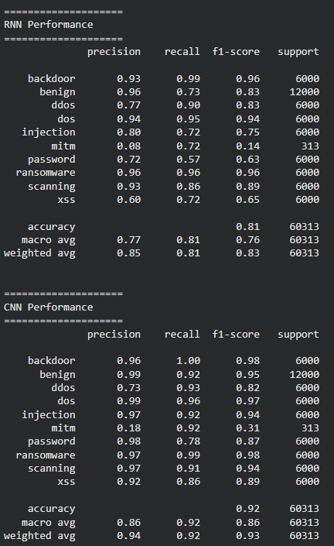
=== Transformer Performance (TEST SET) ===
precision recall f1-score support

backdoor 0.93 0.99 0.96 6000
benign 0.97 0.92 0.94 12000
ddos 0.86 0.93 0.89 6000
dos 0.98 0.93 0.95 6000
injection 0.96 0.90 0.93 6000
mitm 0.33 0.80 0.47 313
password 0.96 0.97 0.96 6000
ransomware 0.95 0.88 0.92 6000
scanning 0.96 0.94 0.95 6000
xss 0.83 0.90 0.86 6000

accuracy 0.93 60313
macro avg 0.87 0.91 0.88 60313
weighted avg 0.93 0.93 0.93 60313

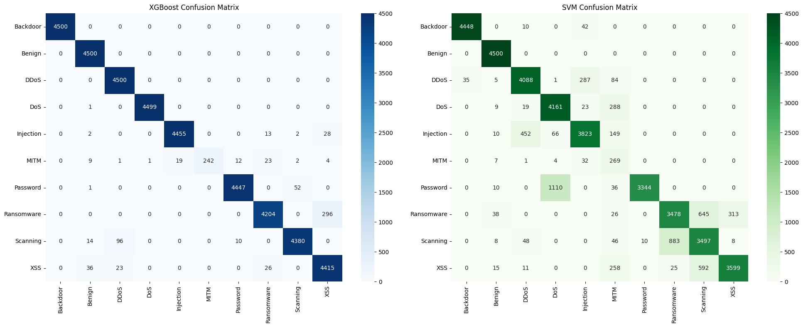

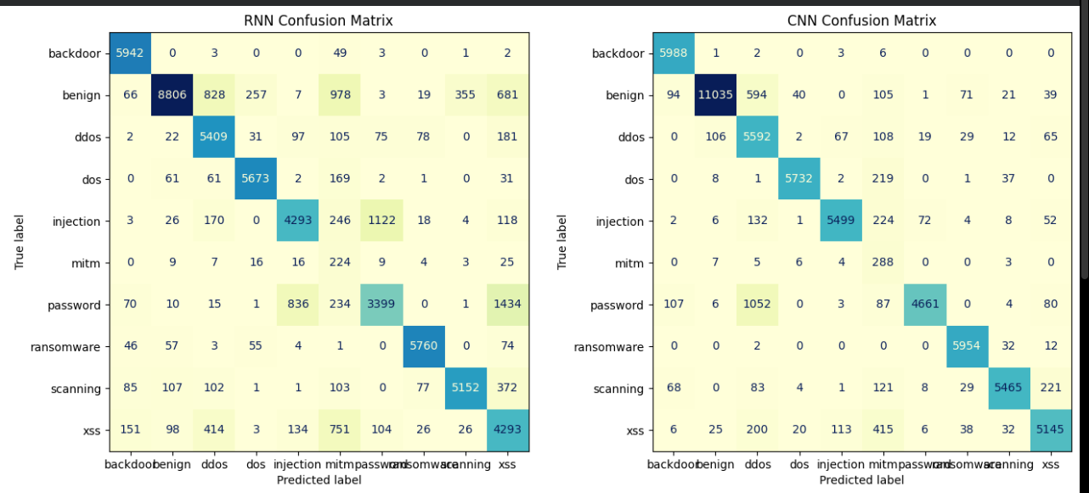

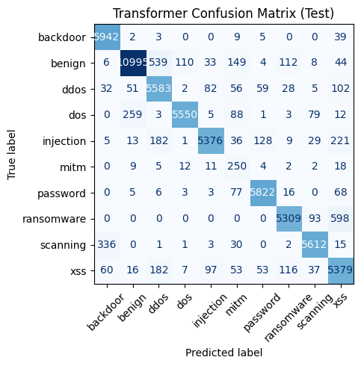

Báo cáo kết quả Training mô hình trên tập IDS2017
Decision Tree overall accuracy: 0.88.
Bagging Classifier overall accuracy: 0.87.
Random Forest overall Accuracy: 0.8573
Best :LightBGM train_acc: 0.8457
Best XGBoost train_acc: 0.9867
Best SVM train_acc: 0.9467
Best Trans Accuracy : 0.9817 tại epoch 79
Best RNN Accuracy : 0.9801 tại epoch 79
Best CNN Accuracy : 0.9952 tại epoch 80
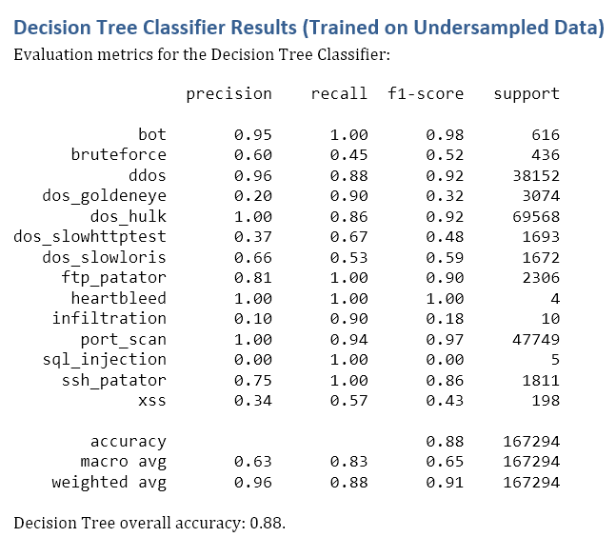
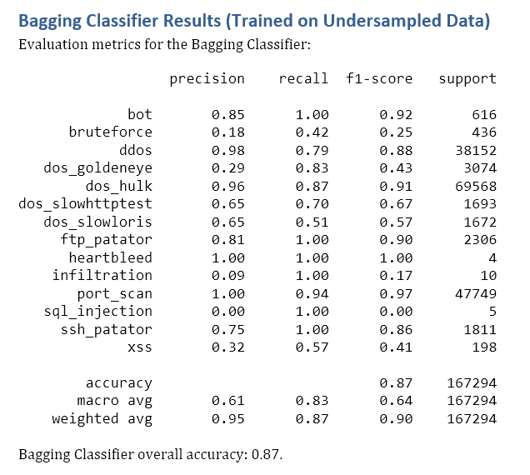
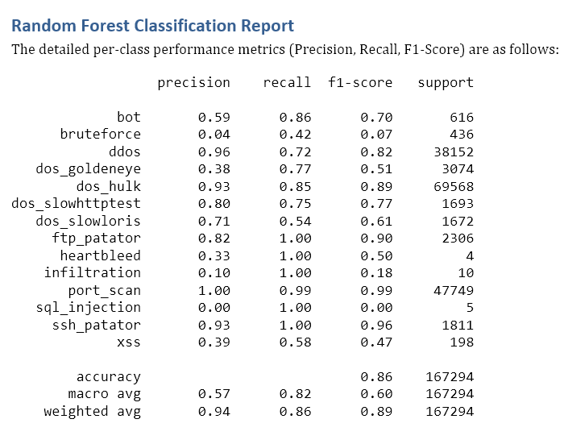
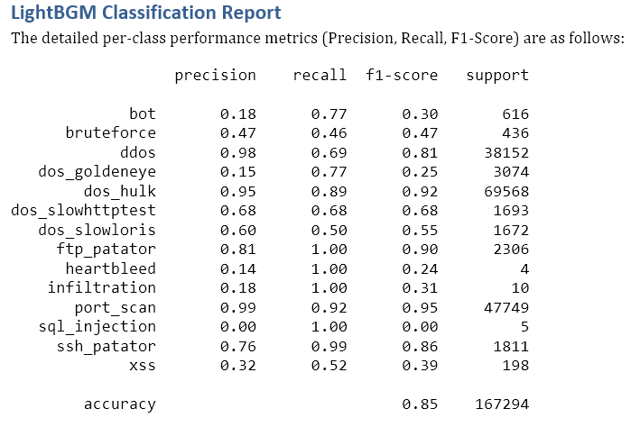
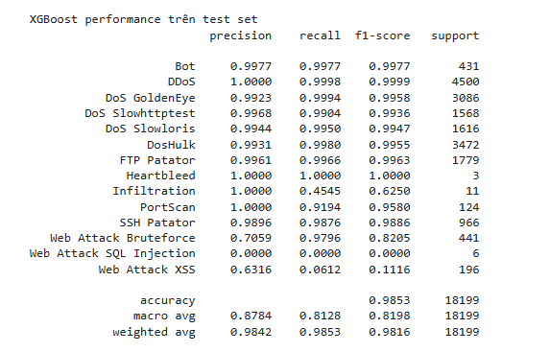
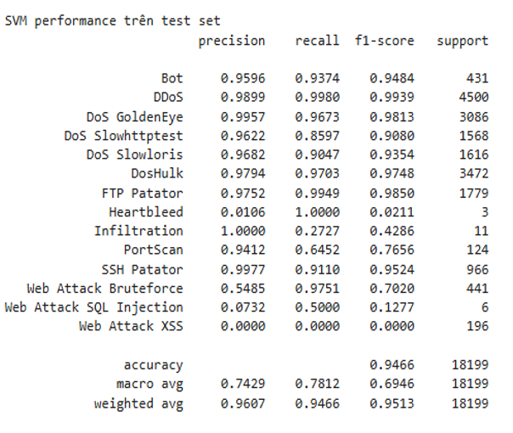
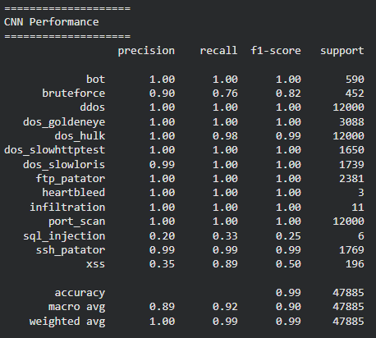
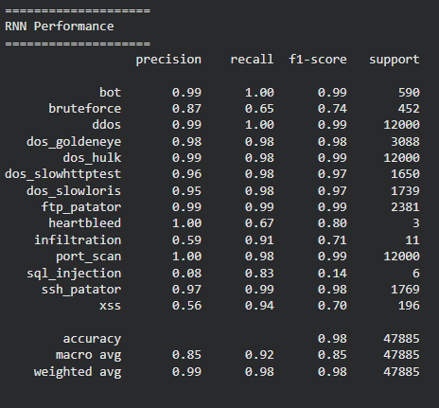
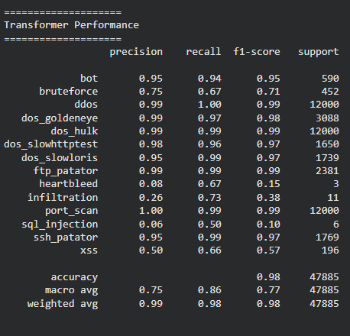
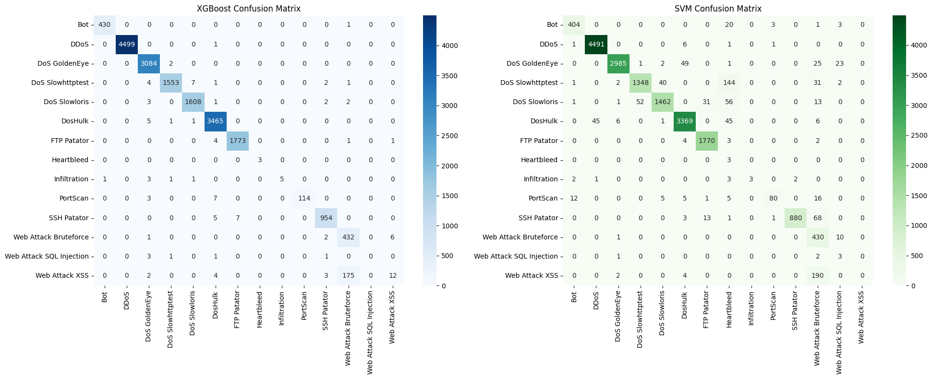
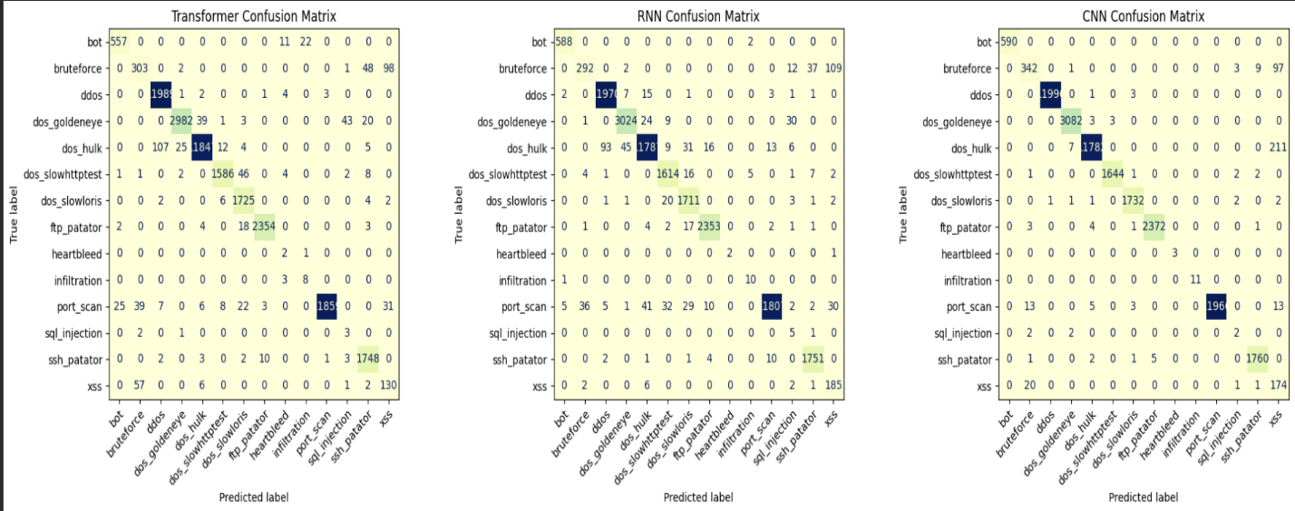

Báo cáo kết quả train mô hình CNN/RNN/Transformer trên tập dữ liệu CTU
Decision Tree overall accuracy: 0.98.
Bagging Classifier overall accuracy: 0.98.
Random Forest overall Accuracy: 0.9791
Best :LightBGM train_acc: 0.9698
Best XGBoost train_acc: 0.94
Best SVM train_acc: 0.83
Best CNN Accuracy : 0.8763
Best RNN Accuracy : 0.8200
Best Trans Accuracy : 0.8115
